ITP4511_assignment

Student | Contribution to the project (%) (Total 100%) | Signature
210146825  Tsai Kwan Yung | 50
210339322  Leung chu Shing | 50

We declare that this is a group project and that no part of this submission has been copied from any other student’s work or from any other source except where due acknowledgement is made explicitly in the text, nor has any part been written for us by another person.

Table of content
Scenario 1
Assumptions 2
System Requirements 2
Hardware Requirements 2
Software Requirements 2
Network Requirements 2
Database Structure 2
Use of MVC 3
Database fields 3
Site Map 3
Use cases 3
Skill checklist 3
System structure on how MVC Model is applied 3
Brief description 3
Conclusion 3

Scenario
EPL, or the Event Point Limited, operates five venues in Hong Kong - Tuen Mun, Sha Tin, Tsing Yi, Lee Wai Lee, and Chai Wan. The primary business of EPL involves providing rental venue services to its members for event organization. To improve the efficiency of the venue booking process, EPL is searching for IT consultants to digitalize the system. Currently, members must check the availability and complete the booking process in person or by phone reservation for each venue. All booking records are manually recorded in a notebook, making them error-prone and challenging for staff to verify. Additionally, it is difficult for senior management to assess the utilization rate of each venue and booking attendance of each member, rendering the current method inefficient. The implementation of a computer system can revolutionize the booking process, allowing for real-time record verification and the generation of statistical reports.

Assumptions
It can be assumed that the current venue booking process at EPL is largely manual and paper-based, which may lead to issues with data accuracy, verifiability, and management oversight. Transitioning to a digital system could potentially address these problems by streamlining procedures, reducing errors, and providing valuable insights into operations. To achieve this goal, EPL is seeking the help of IT consultants to develop a computerized booking platform and revamp their existing.

The System is assumption following condition
- All users must have a valid account to access the system
- All venues have a fixed hourly rate for an entire year
- Users can only book available venues and timeslots
- The system will handle guest list management and booking requests
- Members, staff, and senior management have different access levels and features

System Requirements

Hardware Requirements
Server Side: Recommended minimum server specifications include a quad-core CPU, 8 GB RAM, and 100 GB of storage.

Client Side: The application should be accessible from various client devices, including desktops, laptops, tablets, and smartphones, with a modern web browser installed.

Software Requirements
Database: MySQL 6.0
Java Development Kit (JDK): JDK 8
Web Server: Apache server to serve the application files and handle client requests.

Network Requirements
Internet Connection: A stable and high-speed internet connection is required for the server to ensure optimal performance and accessibility for users.

Firewall: Proper firewall and security configurations should be in place to protect the server

Database Structure
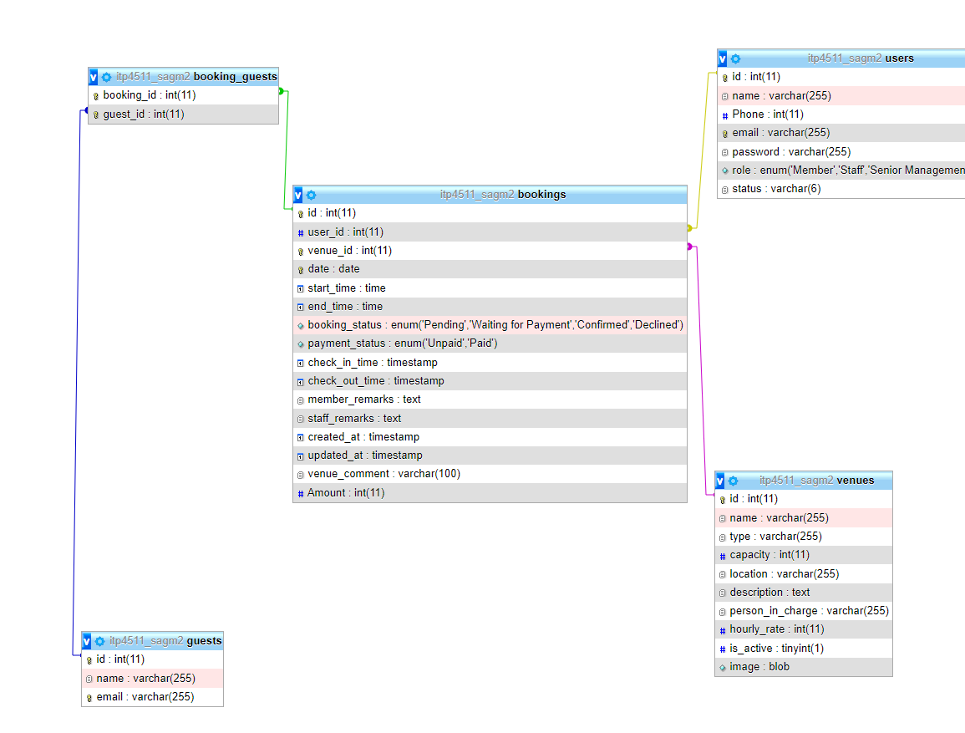

Use of MVC
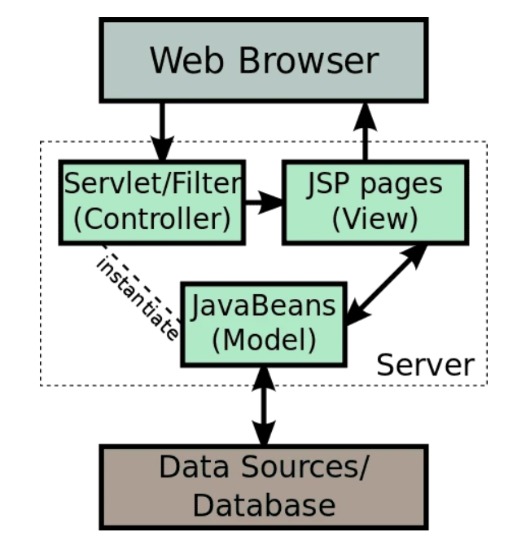

To improve the code structure and separate the business logic from the front end, an Object-Relational Mapping (ORM) was created for the program, which connects the database to the Java controller. Once the data is cleaned, it is then passed to the view, either through a servlet or JSP. This approach helps to enhance the clarity of the code and make it more organized.

Database fields
- Bookings:
Id: int(11)
User_ id : int(11)
Venue_id: int (11)
Date: date
Start_time: time
End_time: time
Booking_status: enum(“peneing”, “Waiting for payment”,”Confirmed”, “Declined”)
Payment_status: enum(“Unpaid”, ‘paid’);
Check_in_time: timestamp
Check_out_time: timestamp
Member_remarks: text
Created_at: timestamp
Updated_at: timestamp
Venue_comment: varchar(100)
Amount: int(11)

- Booking_guests:
Booking_id: int(11)
Guest_id: int(11)

- Guest:
Name:varchar(255)
Email: varchar(255)

- Venues:
Id :int(11)
name: varchar(255)
type:varchar(255)
capacity:int(11)
location:varchar(255)
description: text
person_in_charge: varchar(255)
hourly_rate:int(11)
is_active: tinyint(1)
image: blob

- users:
id : int(11)
name: varchar(255)
phone: int(11)
email:varchar(255)
role: enum(‘Member’,’Staff’, ‘SeniorMangement’)
status: varchar(6)

Site Map
Client:
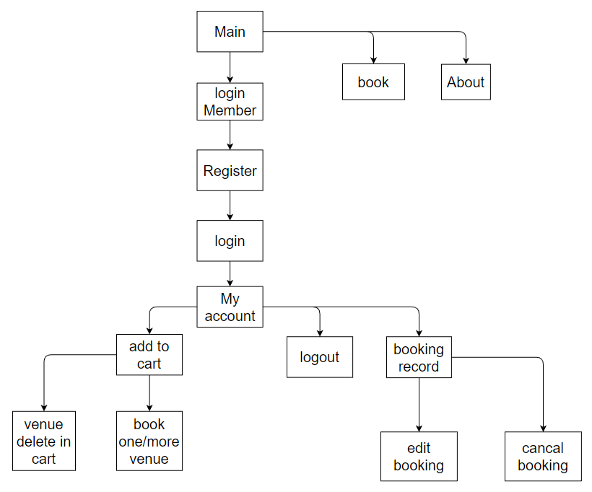

Staff:
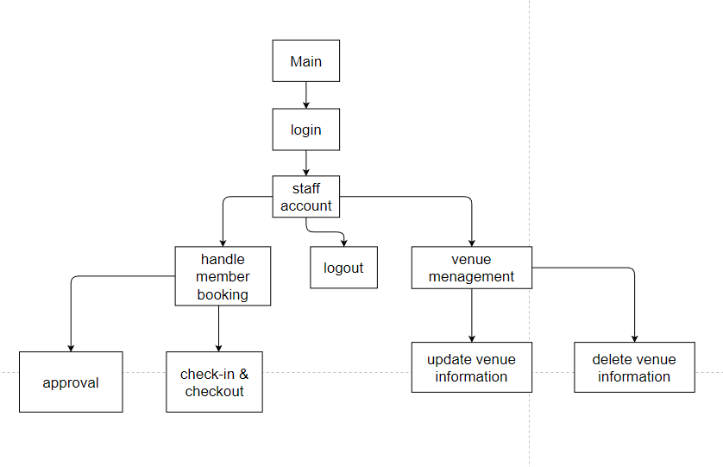

manager
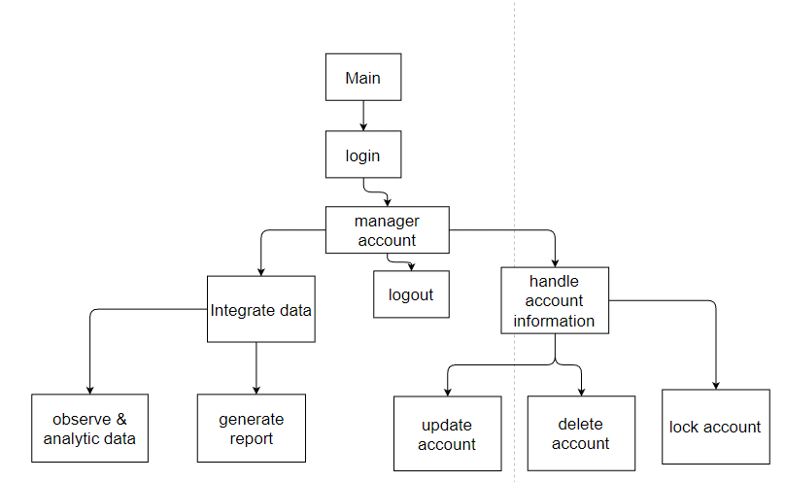

Use cases
Code | Name | URL | Servlet | Who can access
Login |  |  |  | All
1.1 | Login to the System | /Login.jsp | handleLogin.java
1.2 | Register account
Admin |  |  |  | Staff, Senior management
2.1 | Venue Management | /venueManagement.jsp | handleVenueManagement.java
2.2 | Venue Detail | /venueDetail.jsp | handleVenueDetail.java
3.1 | Order Management | /bookingManagement.jsp | handleBookingManagement.java
3.2 | Order Detail | /orderDetail.jsp | handleOrderDetail.java
3.3 | Guest List | /guestlist.jsp | handleGuestList.java
Senior Admin |  |  |  | Senior Management
4.1 | User Management | /userManagement.jsp | handleUserManagement.java
4.2 | User Detail | /userDetail.jsp | handleUserDetail.java
5.1 | Data Analysis | /analysis.jsp | -
5.2 | Select Date(Monthly) | /monthlyReportDatePicker.jsp | -
5.3 | Select Date(Yearly) | /yearlyReportDatePicker.jsp | -
5.4 | Generate Analysis Report | /analysisReport.jsp | handleAnalysisReport
Member

Skill checklist
Skill | URL | Description
HTML | All | create the structure and layout of web pages
CSS | All | style the web pages
JavaScript | All | handling user interactions
MVC Architecture | All related servlet page | separates concerns and promotes maintainable and scalable code
JSP | All page | handle server-side logic, manage database interactions, and generate dynamic content in response to user requests.
Bootstrap 5 | All page | popular CSS framework
Export to CSV | /bookingManagement.jsp | export booking records to CSV files
Canvas.js |  | provides a wide range of chart types, such as bar, line, pie, area, and scatter to suit various data visualization requirements.
TagLib |  | create and use custom tags in the JSP pages.
Session |  | manage user sessions and control access permissions for different roles within a system

System structure on how MVC Model is applied
JSP pages serve as the frontend design and user interface, displaying data from the Model and managing user inputs. They incorporate HTML, CSS, and JavaScript for layout, styling, and client-side interactions.

Controller: Java Servlets handle backend processing, manage user requests, and control data flow between the Model and the View. Servlets accept requests from clients, process these requests by interacting with the Model, and provide a suitable response to the client, often by forwarding the request to a JSP page for rendering.

In the MVC structure, JSP and Servlets collaborate to segregate data management (Model), user interface (View), and system logic (Controller) concerns. This separation encourages maintainable and scalable code, enabling developers to concentrate on specific components without impacting others.

Brief description
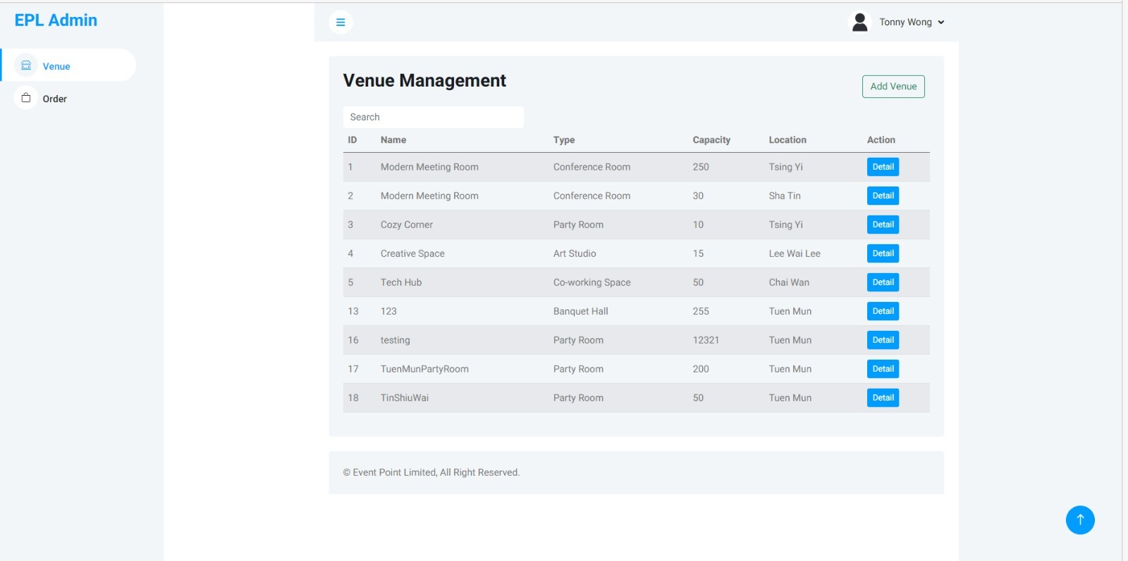
The webpage is designed for the staff and upper management of an organization that oversees venues. It shows a table containing information related to different venues. A search bar is provided which allows users to look for particular venues. The table consists of columns for the venue ID, name, category, capacity, location, and a button to see more details about the venue. The page also consists of a navigation bar and a footer.

The design of the webpage is simple and stylish, featuring a white background with blue highlights. To make the user interface responsive and visually attractive, various libraries and frameworks are employed, such as Bootstrap, Font Awesome, and Owl Carousel. Some JavaScript code is embedded to enhance the search bar's functionality.

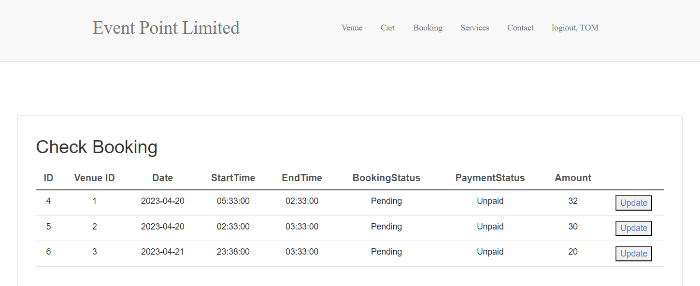
Tables allow you to present data in a structured way, making it easier for users to understand and analyze.

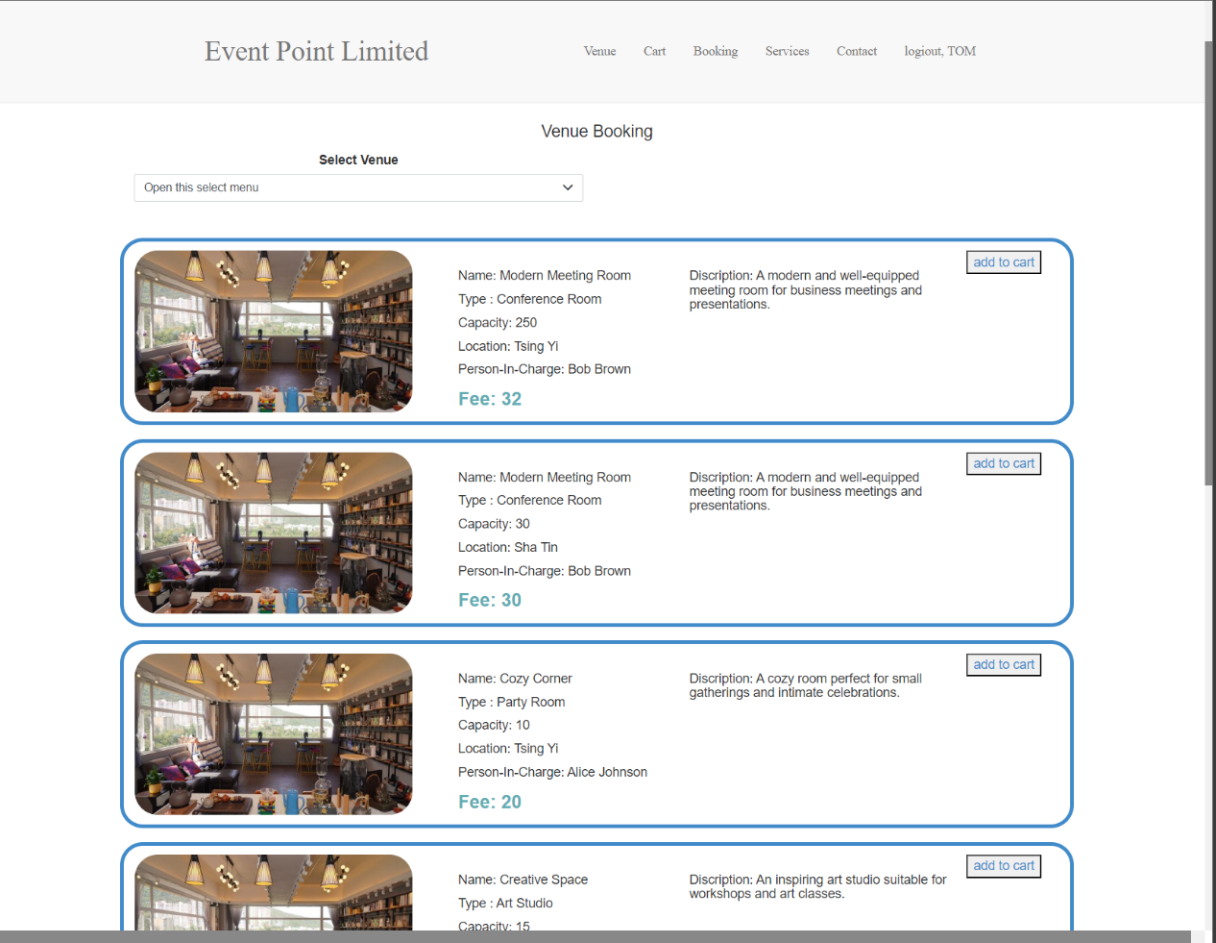

The Netvigator bar provides users with convenient access to a range of Netvigator services, including logout, booking, venue selection, and opening the cart.

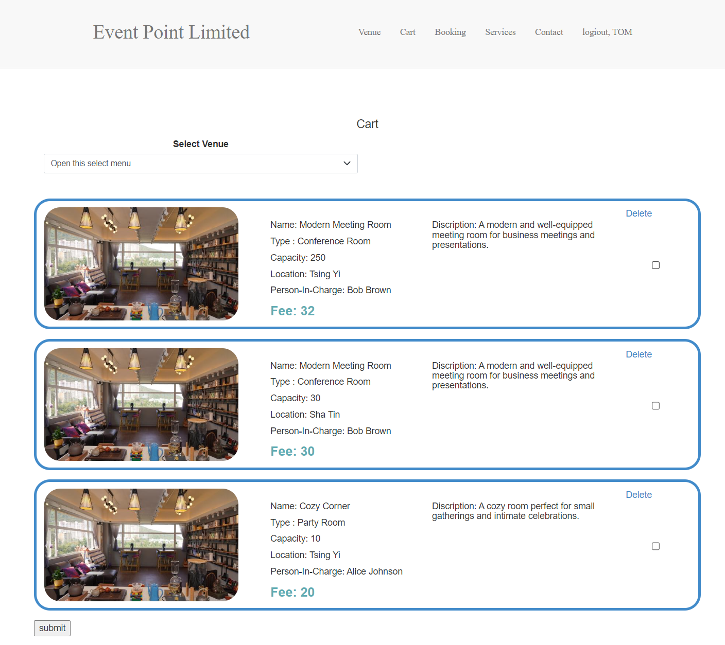

using a shopping cart allows users to select multiple products in one order. In an online website, users can browse through different product pages, add their favorite products to the shopping cart, and finally booking all the products at once.This makes it easier for users to shop for multiple booking and manage their booking history more eaily

Conclusion
In summary, this report gives a thorough overview of the design and main features of our online venue booking application. By using the Model-View-Controller (MVC) architecture with JSP and Servlets, we have made sure that the application is easy to maintain, can grow, and can adapt to future needs. The user interface, made with a responsive layout and Bootstrap 5, provides a consistent and enjoyable experience for users on various devices and screen sizes.

Extra features, like statistical reporting and data visualization using Canvas.js, as well as data export functionality, bring more value to the application. This allows users to get insights and do more analysis on booking data.

In conclusion, our online venue booking application successfully meets the needs of both members and guests. It offers a user-friendly, secure, and efficient platform.

In conclusion, our online venue booking application successfully meets the needs of both members and guests. It offers a user-friendly, secure, and efficient platform. Therefore, Introducing a digital solution has the potential to revolutionize EPL's operations by optimizing their venue booking process, which could have a positive impact on their business results and enhance their competitiveness.

